

# Faculty of Science and Engineering

# 

**Department of Electrical and Electronic Engineering**

**Coursework 2 PLECS Simulation Lab Report**



**ACADEMIC YEAR 2019 / 2020**

**Course Code: EEEE1028**

**Student’s Name** : *JOSHUA TERENCE DOLINTING*

**Student’s ID** : *20104025*

**Course** : Please tick (√)

*Electrical and Electronic Engineering* ( √ )

*Mechatronic Engineering* ( )

**Table of Contents**

1. Introduction (3)
2. Procedure
   1. Investigation of transformer turns ratio and rated load (4)
   2. Measurement of Regulation and Efficiency (5-6)
   3. Determination of transformer equivalent circuit (7)
   4. Measurement of Phase Angle between Input and Output Currents and Voltages (8)
3. Results and Discussions
   1. 3.1 Investigation of transformer turns ratio and rated load (9)
   2. Measurement of Regulation and Efficiency (10-12)
   3. Determination of transformer equivalent circuit (13-16)
   4. Measurement of Phase Angle between Input and Output Currents and Voltages (17-19)
4. Conclusion (20)
5. References (21)

*Numbers in brackets are page numbers*

*Additional Comments requested are shown in page 21*

**1.0 Introduction**

PLECS is a simulation program where it was used to simulate and model the transformer in various situations. The aim of this experiment was to investigate the following:

-transformer turns ratio

-voltage regulation of the transformer

-Transformer Efficiency

-Transformer’s Equivalent Circuit Parameters

To determine the transformer’s turns ratio, the measured input voltage and output voltage are used and calculated with the following formula.

$$a =\frac{V_{in}}{V_{out}}$$

The voltage regulation of the transformer was determined by using measured values of the output and input voltage when the transformer is operating at rated power. While the transformer efficiency is determined using the measured values of the input and output active power. While to determine the transformer’s equivalent circuit, Open Circuit Test and Short Circuit Test was performed. Where Open Circuit Test was able to determine the parameters at the magnetizing branch while Short Circuit Test was able to determine the parameters at the Primary Windings. Theoretical calculations were included to validate the results. Further calculations and analysis details are shown and stated clearly in the Procedure and Results and Discussions section.

**2.0 Procedure**

2.1 Investigation of transformer turns ratio and rated load

1. With reference to cwk2c.plecs file, the following system shown in Figure 1.0 was added into the simulation in transformer1.plecs file, as shown in figure 1.1.

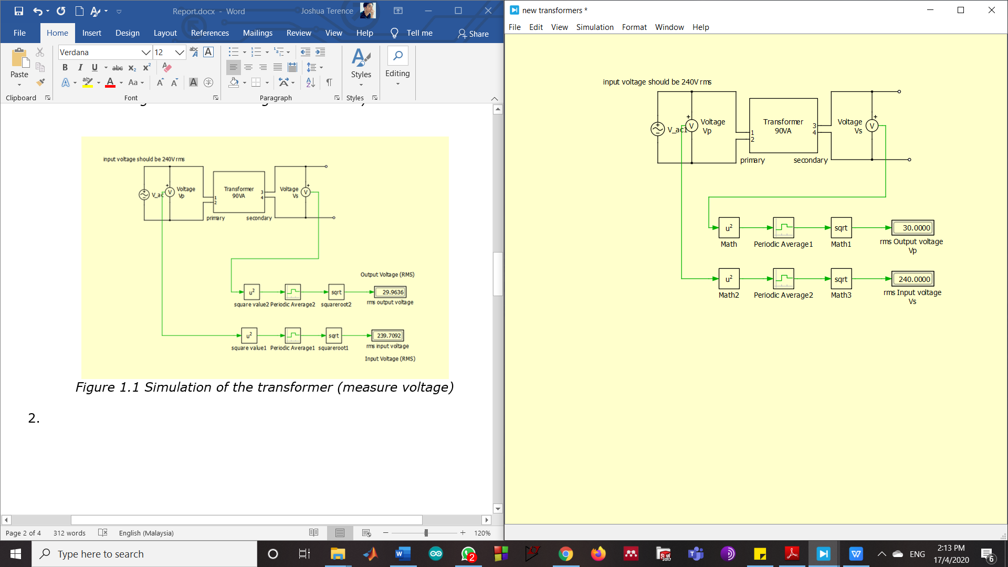

*Figure 1.0 RMS voltage conversion system*



*Figure 1.1 Simulation of the transformer (measure voltage)*

2.2 Measurement of Regulation and Efficiency

1. The load resistance of 4*RL was added into the circuit (Figure 2.0) along with systems to measure the current of the input and output current, primary and secondary active power (Figure 2.1) and Apparent power at the primary side when steady-state is achieved (Figure 2.2).
2. The results were then recorded and repeated using load resistances of 3*RL, 2*RL and RL.

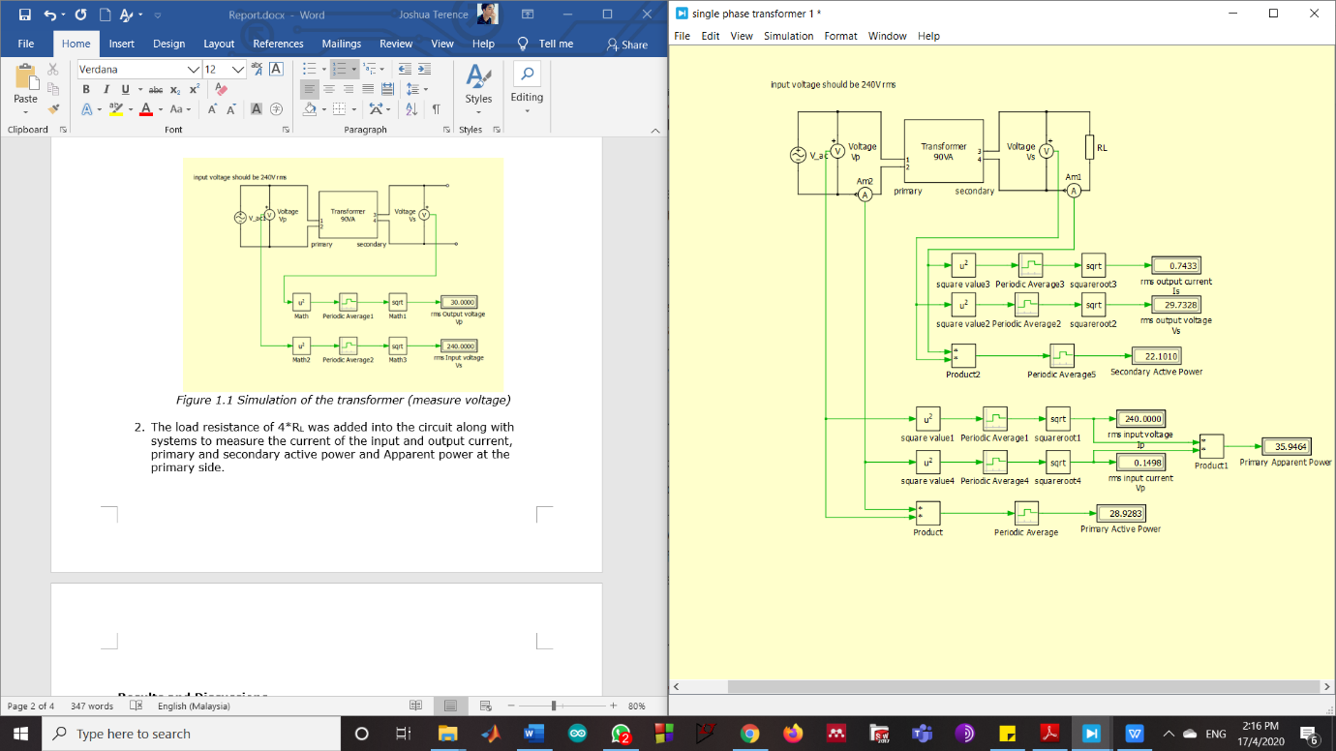

*Figure 2.0 Load resistance added into circuit*

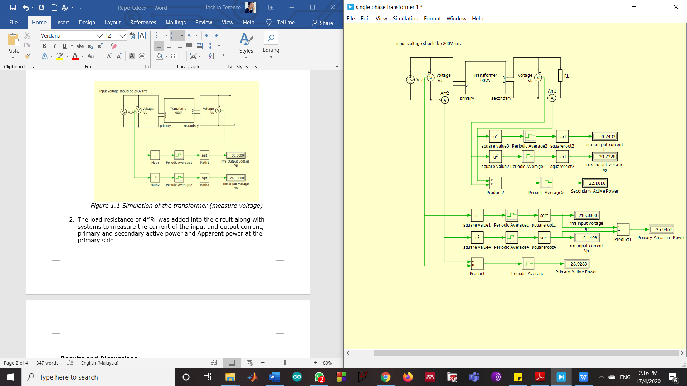

*Figure 2.1 System to measure the current,voltage and power*

**

*Figure 2.2 Additional system to measure Apparent power*



*Figure 2.3 Full Circuit diagram*

2.3 Determination of transformer equivalent circuit

1. The load resistor of the circuit has been removed in order to perform an Open-Circuit Test as shown in Figure 2.4.

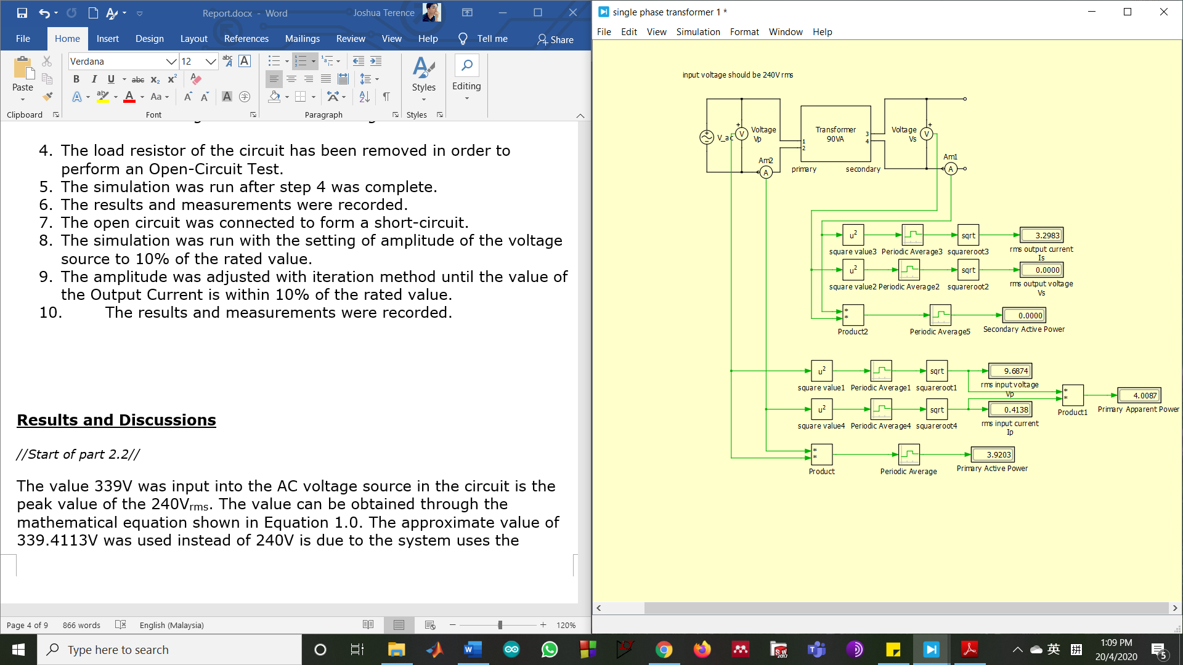

*Figure 2.4 Open Circuit Test*

1. The simulation was run after step 4 was complete.
2. The results and measurements were recorded.
3. The open circuit was connected to form a short-circuit as shown in Figure 2.5.

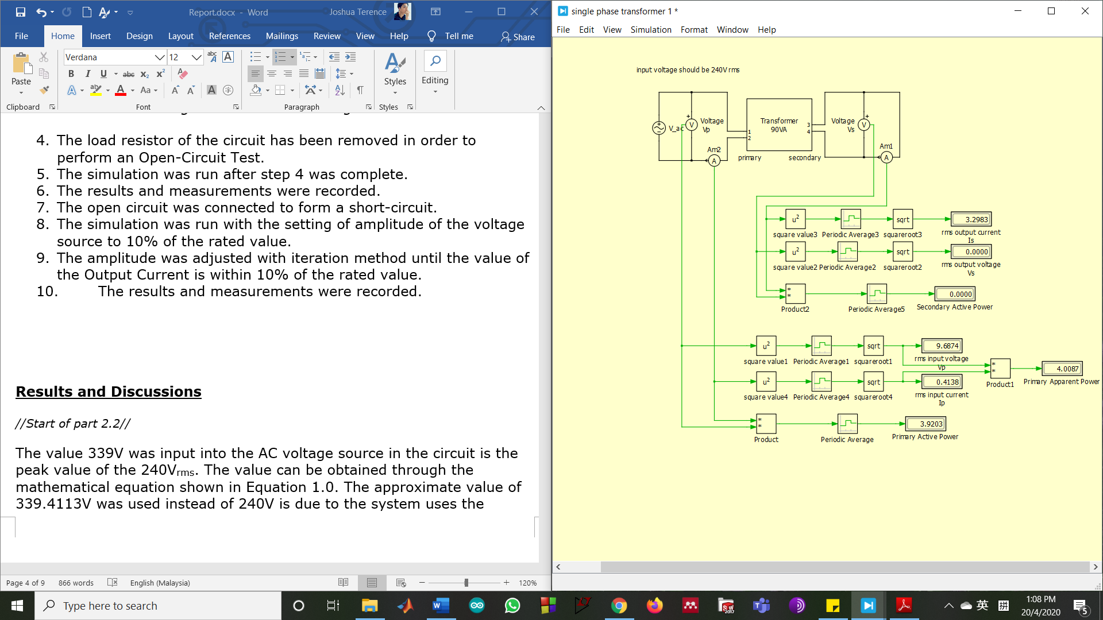

*Figure 2.5 Short-Circuit Test*

1. The simulation was run with the setting of amplitude of the voltage source to 10% of the rated value.
2. The amplitude was adjusted with iteration method until the value of the Output Current is within 10% of the rated value.
3. The results and measurements were recorded.

2.4 Measurement of Phase Angle between Input and Output Currents and Voltages

1. The amplitude of the voltage source was re-adjusted to 339.4113V, which leads to the RMS value of 240V. The resistor of 10ohm was placed into the circuit as shown in Figure 2.0. 4 scopes were added into the circuit to measure the phase angle. The amendments to the circuit are clearly shown in Figure 2.6.

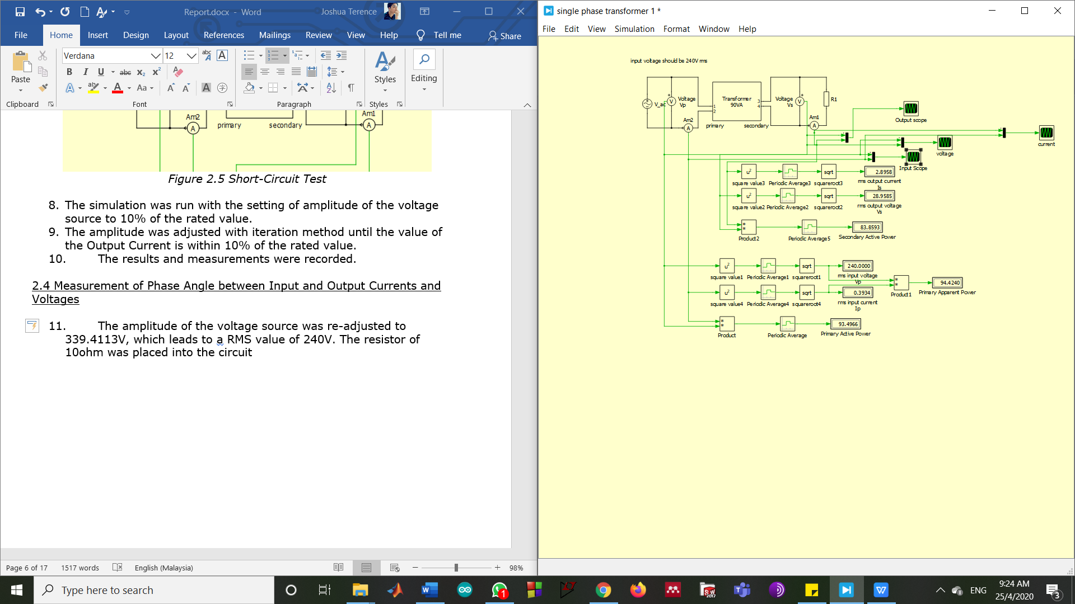

*Figure 2.6 Whole Circuit to measure phase angle*

**3.0 Results and Discussions**

3.1 Investigation of transformer turns ratio and rated load

The value 339V was input into the AC voltage source in the circuit is the peak value of the 240Vrms. The value can be obtained through the mathematical equation shown in Equation 1.0. The approximate value of 339.4113V was used instead of 240V is due to the system uses the parameter amplitude for the AC voltage source, therefore a peak value is needed instead of a RMS value.

$$240 × \sqrt{2} =339.4113V$$

*Equation 1.0*

By running the simulation, in Figure 1.1 it shows the Input voltage 240.0000Vrms, while the Output Voltage is approximately equal to 29.7327Vrms or 30Vrms. Thus, the turns ratio(a) of the transformer can be calculated which is shown in Equation 2.0. The approximate value of 8 is obtained as the turns ratio.

$$a =\frac{240}{30}=8$$

*Equation 2.0*

While the MVA rating on the transformer is 90VA, the rated current for the secondary side of the transformer can be calculated with the formula S = VI. Where S is the apparent power, V is the voltage and I is the current. The detailed calculations are shown in Equation 3.0

$$S =VI$$

$$I=\frac{S}{V}= \frac{90}{30}=3A$$

*Equation 3.0*

The load resistance can be measure now with the current obtained in Equation 3.0 by using Ohm’s Law (V=IR).

$$R_{L}=\frac{V}{I}= \frac{30}{3}=10Ω$$

*Equation 4.0*

3.2 Measurement of Regulation and Efficiency

The results for the test conducted are shown in Table 1.0.

|  |  |  |  |  |  |  |
| --- | --- | --- | --- | --- | --- | --- |
| Load Resistance ( $Ω)$ | Input Current rms  Ip (A) | Output voltage rms  Vs (V) | Output Current rms  Is (A) | Apparent Power (VA) | Input Active Power (W) | Output Active Power (W) |
| 40 | 0.1315 | 29.7328 | 0.7433 | 31.5536 | 28.9231 | 22.1010 |
| 30 | 0.1600 | 29.6448 | 0.9882 | 38.4093 | 36.2682 | 29.2937 |
| 20 | 0.2183 | 29.4702 | 1.4735 | 52.3995 | 50.8286 | 43.4247 |
| 10 | 0.3934 | 28.9585 | 2.8958 | 94.4240 | 93.4966 | 83.8593 |

*Table 1.0 Table of measured data for part 2.3*

*MATLAB Code for Graph Plot*

x=[0.7433 0.9882 1.4735 2.8958]

y=[29.7328 29.6448 29.4702 28.9585];

x1=0.7433;

x2=2.8958;

y1=29.7328;

y2=28.9585;

m=(y2-y1)/(x2-x1); % calculate gradient

plot(x,y);

title('Graph of Vs against Is')

ylabel('Secondary Voltage, Vs') % label for y axis

xlabel('Secondary Current, Is') % label for x axis

fprintf("%f",m);

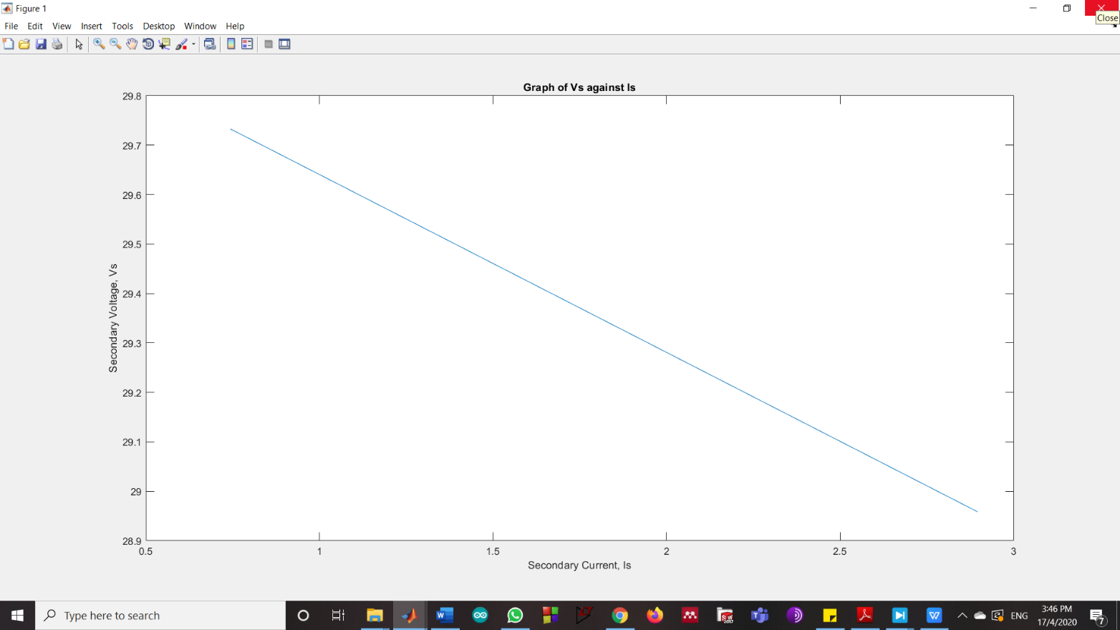

*Figure 3.0 Graph for Vs against I~~s~~*

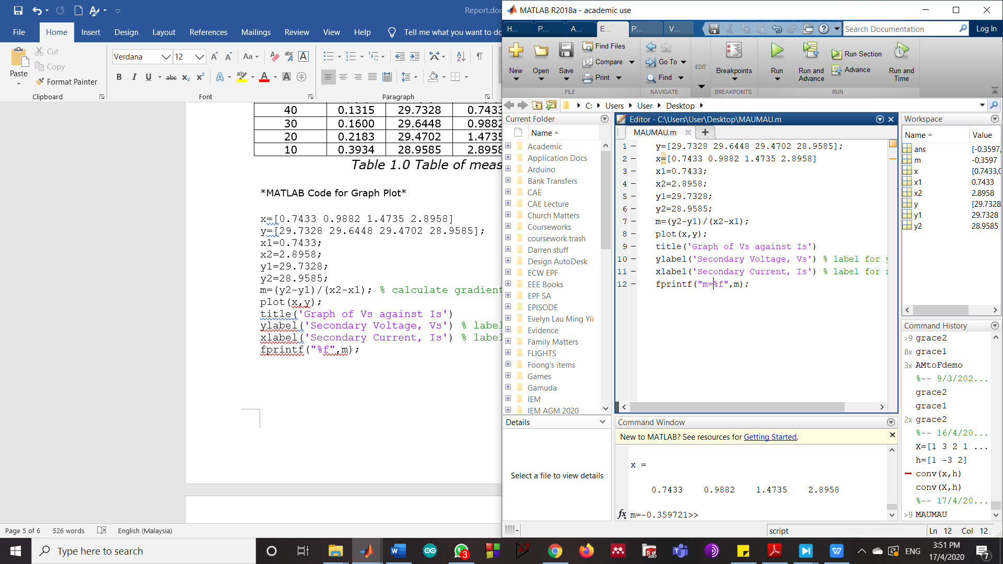

*Figure 3.1 Gradient of the Slope*

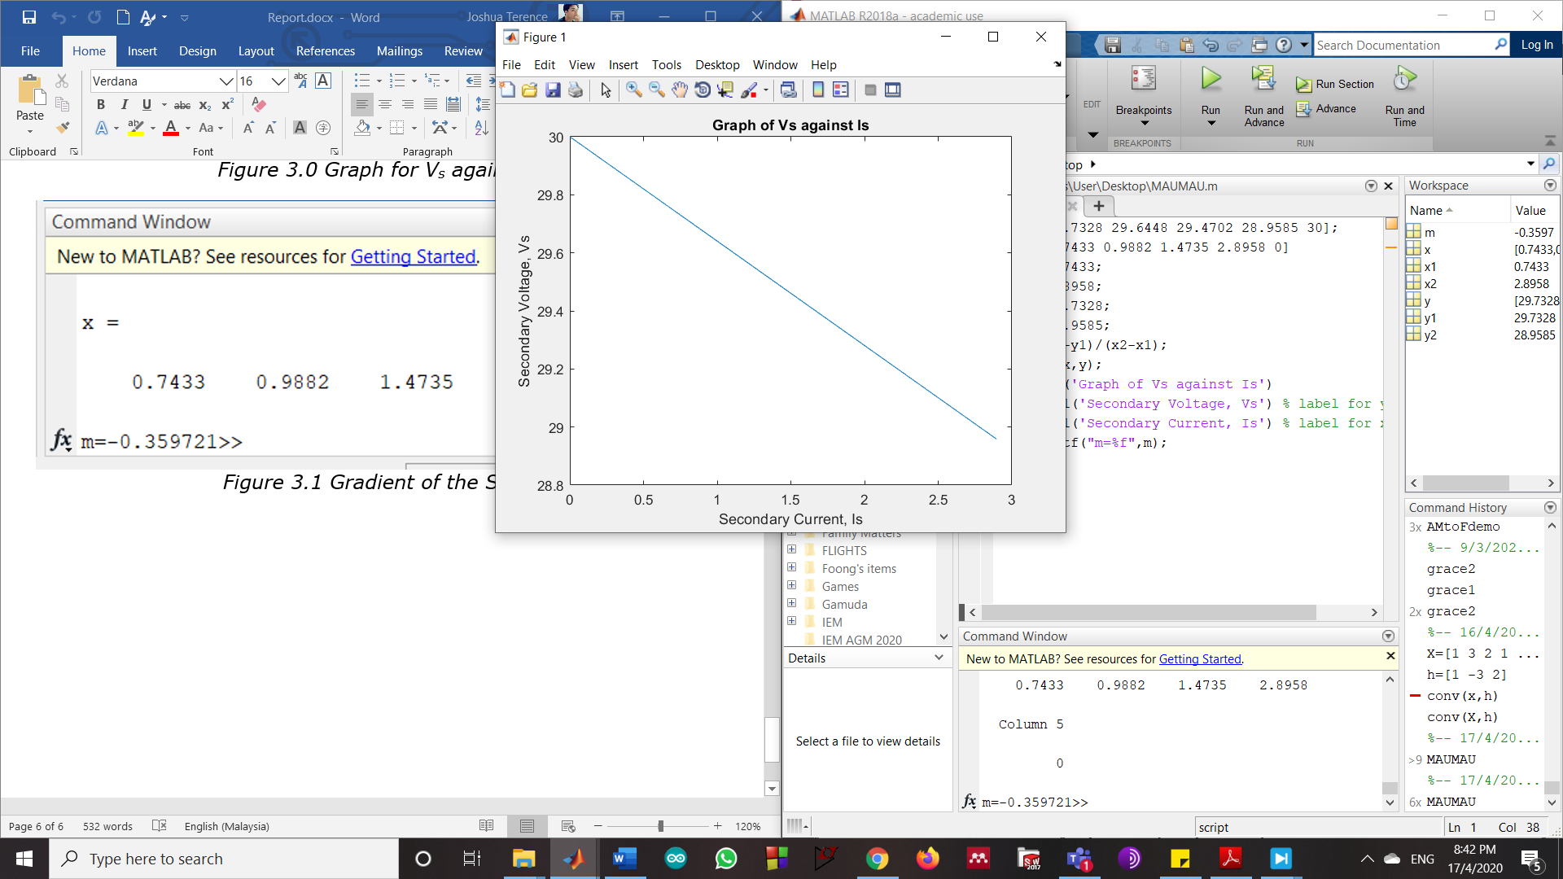

*Figure 3.2 Slope of the graph to show Y-intercept*

According to the Table 1.0, when operating at rated power, the efficiency and voltage regulation can be calculated based in the highlighted values stated in the table.

Efficiency = $\frac{P_{output}}{P_{input}}×100\% = \frac{83.8593}{93.4966}×100\%=89.6924\%$

*Equation 5.0*

Voltage Regulation = $\frac{V_{s no load}-V_{s Full Load}}{V_{s Ful load}}×100\%$

Voltage Regulation = $\frac{30-28.9585}{28.9585}×100\%=3.5965\%$

*Equation 6.0*

The slope or gradient of the graph shows the Voltage Regulation (VR) of the transformer. The Figure 3.3 shows the detailed workings on the VR.

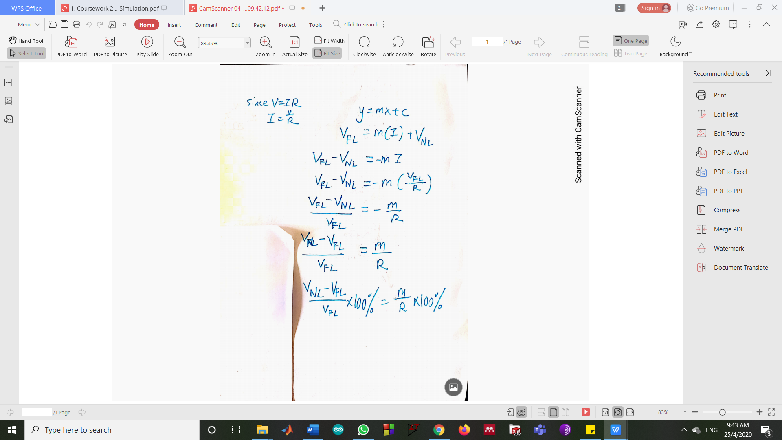

*Figure 3.3 Proof of the slope to be VR*

3.3 Determination of transformer equivalent circuit

Open Circuit Test

|  |  |  |  |
| --- | --- | --- | --- |
| Primary Current rms (A) | Primary Voltage rms (V) | Primary Active Power (W) | Primary Apparent Power (VA) |
| 0.0592 | 240.00 | 6.6236 | 14.2095 |

*Table 2.0 Measurements of Open Circuit Test*

In this terms, Primary current is Ip and Primary Voltage is Vp.

Ic can be calculated based on the formula P=VI, detailed calculations is shown in Equation 7.0 $.$

$$\frac{P}{V_{p}}=\frac{6.6236}{240}=0.0276A=I_{c}$$

*Equation 7.0*

Im can be calculated by using the Pythagoras theorem as shown in Equation 8.0.

Im=

Im=

Im=0.0524A

*Equation 8.0*

Rc can be calculated based on the formula $P=\frac{V^{2}}{R}$

$R_{c}=\frac{V_{p}}{I_{c}}$ = $\frac{240}{0.0276}$ = $8695.6522Ω$

*Equation 9.0*

Xm can be calculated based on the formula V=IR (Ohm’s Law)

$X_{m}=\frac{V_{p}}{I_{m}}$ = $\frac{240}{0.0524}=4580.1527Ω$

*Equation 10.0*

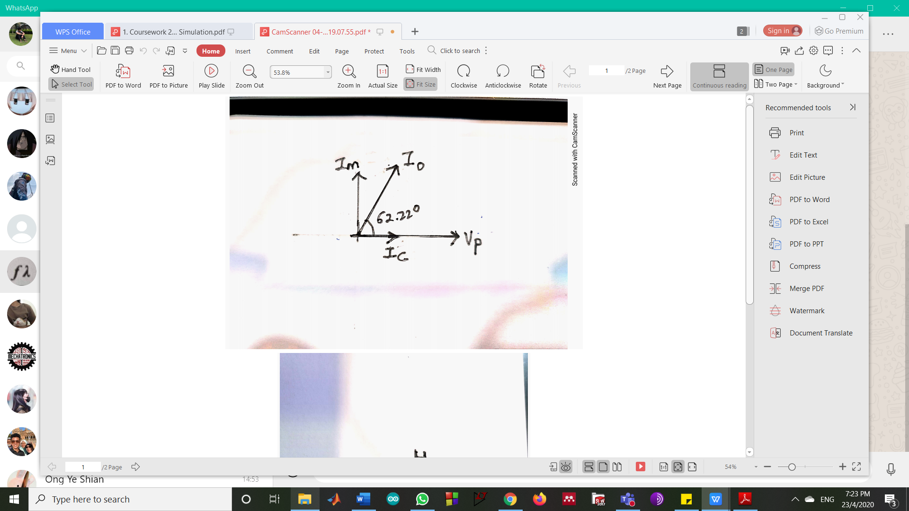

*Figure 4.0 Phasor Diagram of Vp,Io,Ic and Im*

Theoretical Calculations (Open Circuit Test)

Power factor:

$$θ=\cos^{-1}\left(\frac{P}{V_{p}{×I}_{p}}\right)=\cos^{-1}\left(\frac{6.6236}{240×0.0592}\right)=62.21°$$

Admittance (Parallel Impedance):

$$Y=\frac{I_{p}}{V_{p}}∠θ°=\frac{0.0592}{240}∠62.21°=(1.1500×{10}^{-4}+j2.1821×{10}^{-4})Ω$$

Rc:

Rc=

Xm:

Xm=

For Rc there is no percentage difference due to the experimental values and theoretical values are similar. While for the Xm there is a percentage difference of 0.0565% which is considerably negligible as the difference is minor which is within a range of 5% from the theoretical value.

Percentage Difference = $\frac{experimental value-theoretical value }{theoretical value}×100\%$

Percentage Difference = $\frac{4580.1527-4582.7414}{4582.7414}×100\%=-0.0565\%$

Short-Circuit Test

|  |  |  |  |
| --- | --- | --- | --- |
| Primary Current rms (A) | Primary Voltage rms (V) | Primary Active Power (W) | Primary Apparent Power (VA) |
| 0.4138 | 9.6874 | 3.9203 | 4.0087 |

*Table 3.0 Measurements of Short-Circuit Test*

In order for the output current to be within a 10% range from the rated value 3A, the amplitude of the voltage source was adjusted to a value of 13.7000V (peak value) which is approximately 4.0364% from the rated value 339.4113V (peak value). The output current in this case is 3.2983A (rms value).

Since ${I'}_{s}=I_{P}$,

$$V_{R}=\frac{P}{{I'}_{s}}=\frac{3.9203}{0.4138}=9.4739V$$

*Equation 11.0*

$$V_{X}=\sqrt{{V_{P}}^{2}-{V_{R}}^{2}}=\sqrt{{9.6874}^{2}-{9.4739}^{2}}=2.0226V$$

*Equation 12.0*

$$R=\frac{V_{R}}{{I'}_{s}}=\frac{9.4739}{0.4138}=22.8948Ω$$

*Equation 13.0*

$$X=\frac{V_{X}}{{I'}_{s}}=\frac{2.0226}{0.4138}=4.8879Ω$$

*Equation 14.0*

Equation 11.0 until Equation 14.0 shows the calculation for voltages of R and X, winding resistance of R and winding leakage reactance X respectively.

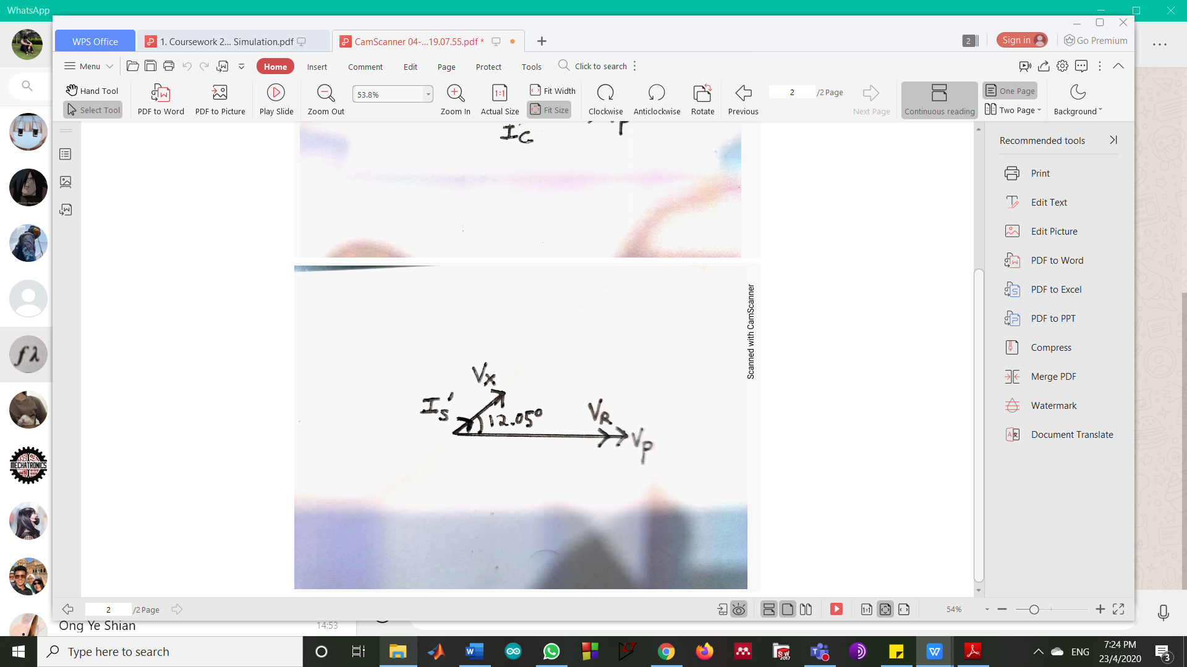

*Figure 4.1 Phasor Diagram of Vp,VR,Vx and Is’*

Theoretical Calculations (Short Circuit Test)

Power factor:

$$θ=\cos^{-1}\left(\frac{P}{I_{p}{×V}_{p}}\right)=\cos^{-1}\left(\frac{3.9203}{0.4138×9.6874}\right)=12.05°$$

Admittance (Series Impedance):

$$Y=\frac{V_{p}}{I_{p}}∠θ°=\frac{9.6874}{0.4138}∠12.05°=(22.8950+j4.8874)Ω$$

R=22.8950Ω

X=4.8874Ω

For R and X there is no percentage difference due to the experimental values and theoretical values are approximately similar where the values differ only by 0.0002 and 0.0005 respectively.

3.4 Measurement of Phase Angle between Input and Output Currents and Voltages

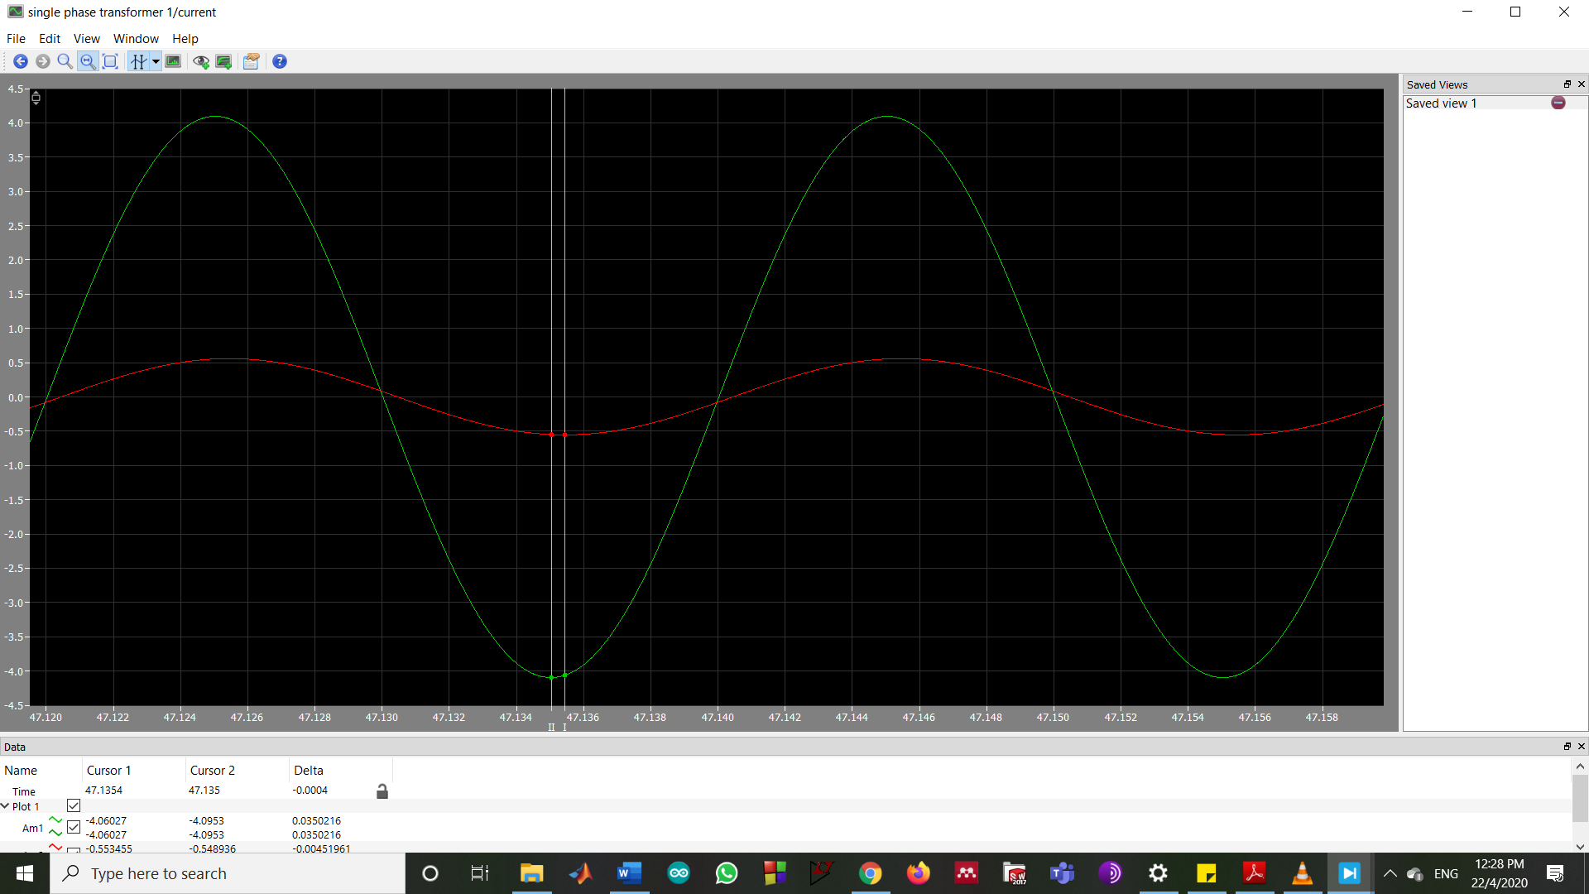

*Figure 5.0 Plot of Input current and Output current*

Based on the Figure 5.0, it clearly states that the delta or difference in phase between the input and output current is 0.0004, where the input current (Ip) is 0.3934Arms while the output current (Is) is 2.8958Arms at steady-state conditions. The phase angle is calculated and shown in Equation 15.0, and the phasor diagram for both currents are illustrated in Figure 5.1.

Phase Angle = $\frac{Delta}{0.02}×360=\frac{0.0004}{0.02}×360=7.2°$

*Equation 15.0*

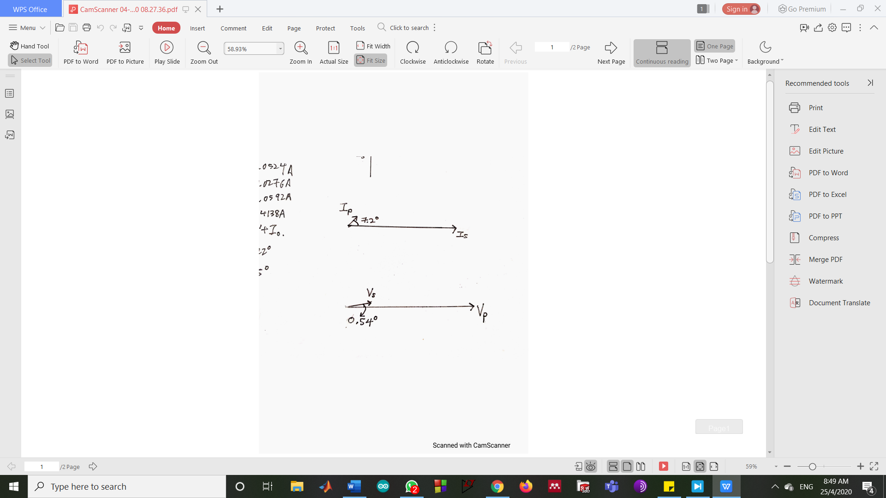

*Figure 5.1 Phasor diagram for currents Ip and Is*

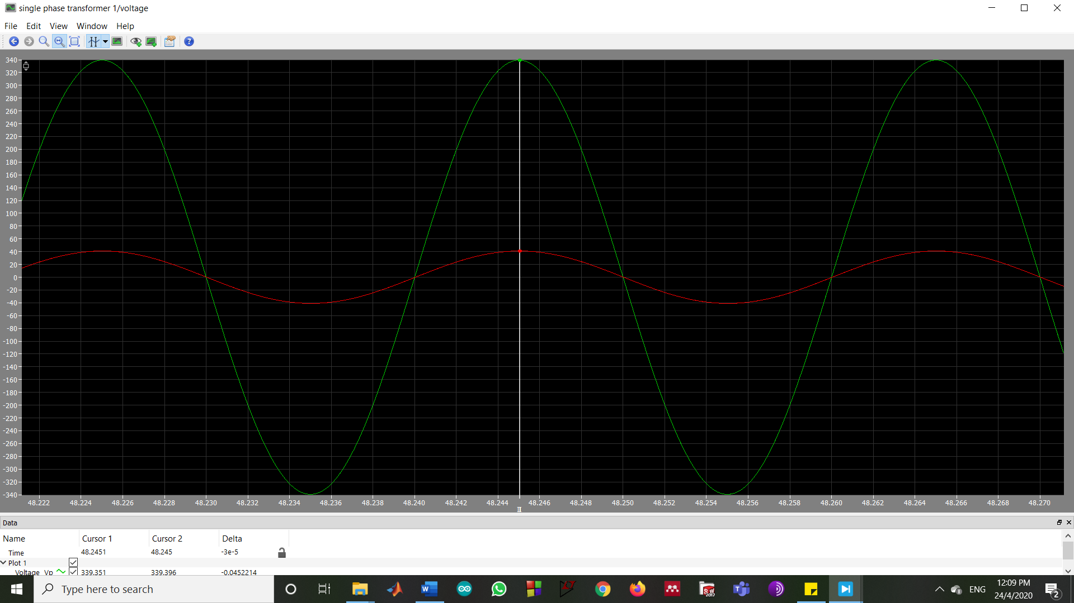

*Figure 6.0 Plot of Input Voltage and Output Voltage*

Based on the Figure 6.0, it clearly states that the delta or difference in phase between the input and output voltage is 3×10-5, where the input voltage (Vp) is 240.00Vrms while the output voltage (Vs) is 28.9585Vvrms at steady- state conditions. The phase angle is calculated and shown in Equation 15.1 and the phasor diagram for both voltages are illustrated in Figure 6.1.

Phase Angle = $\frac{Delta}{0.02}×360=\frac{ 3×{10}^{-5}}{0.02}×360=0.54°$

*Equation 15.1*

**

*Figure 6.1 Phasor diagram for voltages Vp and Vs*

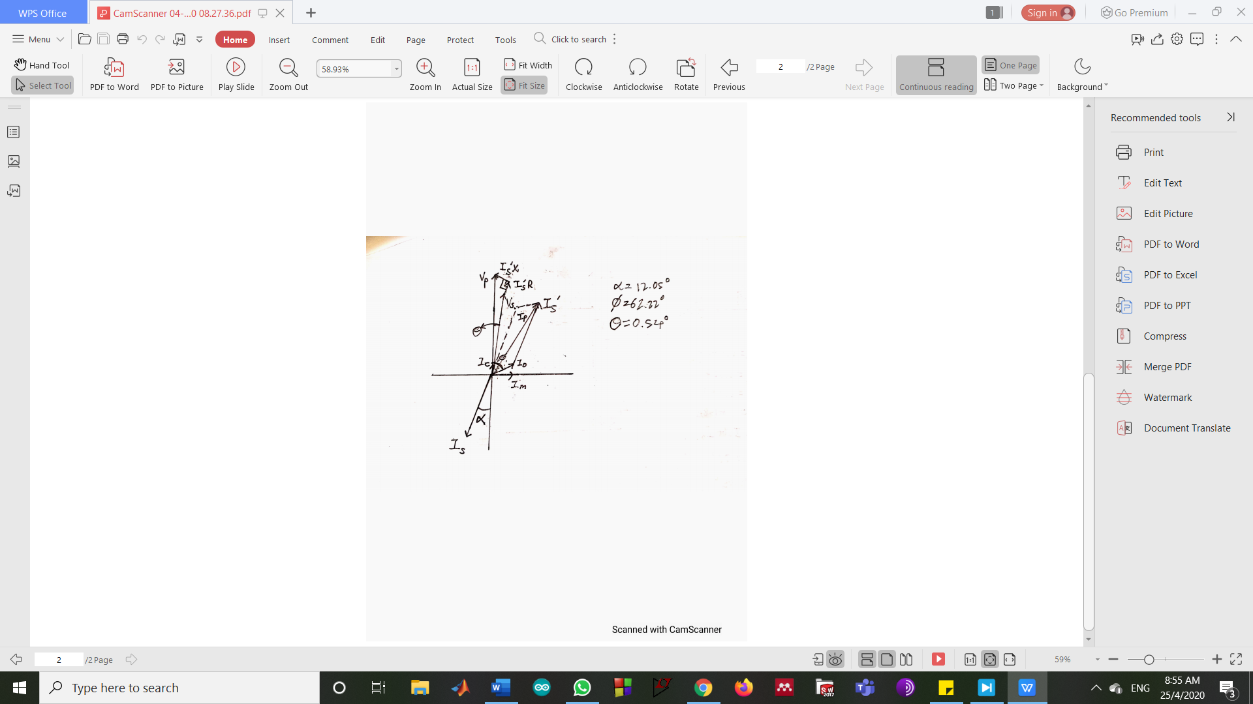

*Figure 7.0 Phasor diagram for compilation of voltages and currents in the transformer*

**4.0 Conclusions**

In conclusion, all the objectives of the experiment were able to be completed. The PLECS simulation results were considered as accurate as the equivalent circuit parameters have negligible percentage difference with the theoretical values calculated.

**5.0 Reference**

[1] Chapman S.J. (1985) **Electric Machinery Fundamentals**. pp.65-108.

[2] Gonzalez-Longatt F. (2019) **Electrical Science A.** [online] Available at: <https://www.researchgate.net/project/Electrical-Science-A>

[accessed 25th April 2020]

[3] Hughes E. (2008) **Hughes Electrical and Electronic Technology Tenth Edition.** pp.680-706.

Additional Comments

Regarding the coursework, the instructions were considerably clear and understandable. However, in section 2.5 it would be preferred if the required voltages and currents could be included to allow precise works to be done. Lastly, a precise and detailed marking rubric is highly suggested in order for students to understand the requirement of the report.